Keeping My Promise 2023 Board of Directors

Returning to the Board of Directors for a second term is Mr. Da’Marrion Fleming. Da’Marrion is the Executive Director of Sowing Seeds with Faith, a 501c3 non-profit serving the Greater Louisville,KY community. SSWF specifically targets unrepresented youth through mentoring, tutoring services, and youth enrichment programming. Partnerships include JCPS, Norton’s Healthcare, Louisville Urban League, Community Foudation of Louisville to name a few. Da’Marrion is a member of Omega Psi Phi Fraternity Inc.
Mr. Da'Marrion Fleming

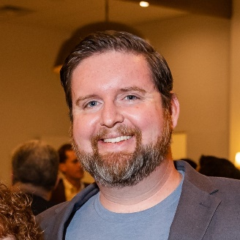
Returning to the Board of Directors for a second term is Mr. Michael Magnus (Fort Worth, TX). Michael is the owner and operator of Magnus Opus, a consulting agency specializing in Search Engine Optimization and Digital Marketing. In addition, Michael is the President for AAF-Fort Worth, a local chapter of the American Advertising Federation, a national advertising organization and community. Michael’s other prior experience includes teaching at both UT-Arlington and Texas Christian University.
Mr. Michael Magnus
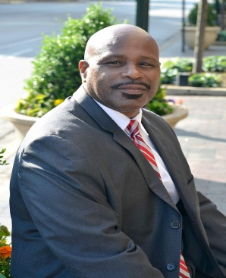
Returning to the Board of Directors for a second term is Dr. Roger Cleveland (Lexington, KY) . Dr. Cleveland is the owner and Principal Consultant for Millenium Learning Concepts (MLC), a consultant firm with specialities in Diversity, Equity, & Inclusion. Dr. Cleveland is also a seasoned higher education professional with both teaching and leadership experience. In addition to MLC, Dr. Cleveland is a member of Eastern Kentucky University serving as Faculty, Diversity and Development; founder/mentor with Black Males Working with First Bracktown Baptist of Lexington, KY. Dr. Cleveland is a member of Kappa Alpha Psi Fraternity Inc.
Dr. Roger Cleveland

Newest Additions to the Board of Director
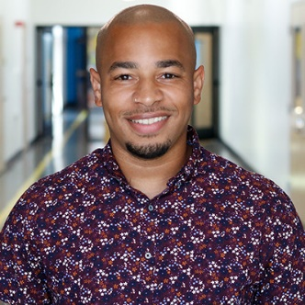
Joining Keeping My Promise Inc. as a Board of Director is Dr. Ronald Sickles (Nashville, TN). Dr. Sickles is a founding member of KIPP Nashville and currently serves as the Dean of Culture at KIPP Antioch College Prep Elementary. Prior to endeavors with KIPP Nashville, Dr. Sickles experiences includes Teach for America and City Year. Dr. Sickles was asked join the board bringing expertise in areas such as: curriculum development; youth engagement; events and external relations. Dr. Sickles is a member of Alpha Phi Alpha Fraternity Inc.
Mr. Ronald Sickles

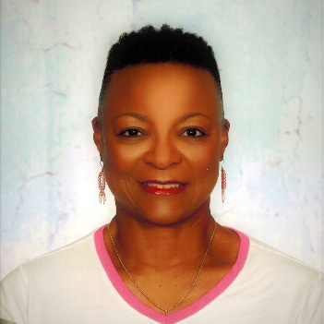
Joining Keeping My Promise Inc. as a Board of Director is Ms. Gwendolyn Tomlin (Fort Worth, TX). Ms. Tomlin is a retired Marine veteran and seasoned educator. Ms. Tomlin has an expertise in special education, along with student development. Currently, Ms. Tomlin is a member of Crowley ISD where she serves as the district Special Education Development. Ms. Tomlin was asked to join the board bringing a variety of education expertise, in addition to her dedication of youth advocacy. Ms. Tomlin has been a sounding board the past two years through our work within Crowley ISD.
Ms. Gwendolyn Tomlin

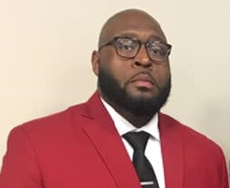
Joining Keeping My Promise Inc. as a Board of Director is Mr. Dominique Hudspeth (Louisville, KY). Mr. Hudspeth has been an avid philanthropist and supporter of Keeping My Promise’s inception. Currently, Mr. Dominique Hudspeth is an Account Specialist with AstraZeneca. Mr. Hudspeth was asked to join the board as a community member at large who desires to serve youth via exposure to new endeavors. Mr. Hudspeth has a tremendous network some of which could be pivotal to Keeping My Promise’s growth and expansion. Mr. Dominique Hudspeth is a member of Kappa Alpha Psi Fraternity Inc.
Mr. Dominique Hudspeth
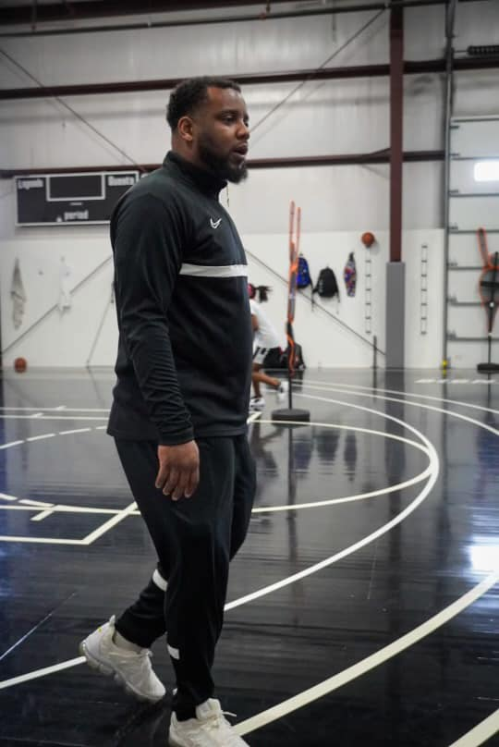
Joining Keeping My Promise Inc. as a Board of Director is Mr. Derrance Lawson (Louisville, KY). Mr. Derrance Lawson is currently an educator and coach (basketball) within JCPS (Louisville, KY). Mr. Lawson has been an avid supporter of Keeping My Promise since its inception and was asked to join as a “boots on the ground educator.” Mr. Lawson’s role within the school provides Keeping My Promise with daily insights regarding: gaps within the school system; student engagement & needs; behavioral and other trauma related issues. Mr. Lawson, also is the founder of the Well Rounded Foundation, which aims to support athletes and youth with mental wellness through athletics.
Mr. Derrance Lawson

Notes
Keeping My Promise Inc. still seeks to add members to the Board of Directors with an emphasis on identifying an accountant and attorney. Notably, having two board of directors with these specialties provides Keeping My Promise with in-house representatives to review our final status year-round, while having legal counsel readily available.

